Google I/O 2016?
- Android N
- Chrome OS
- Virtual reality
- Android Wear
- Android Auto
- Self-driving cars
- Internet of Things
- Project Ara
- Nexus 7 (2016)
- New messaging platform
- Project Tango
- Project Fi
Android N
We expect that Android will receive a relatively major update this year. This was Google's promise in 2015, and since it's been two years since the last big overhaul with Android Lollipop (there is usually a two-year gap between significant changes on Android), we think it will deliver.
Google I/O 2016 should see the introduction of what we are calling Android N. Google started introducing developer preview versions of its upcoming software releases two years ago, with Android L. These preview versions allow developers to get to grips with the latest Android software before its final release.
Android N Support Multi Window Support Feature.
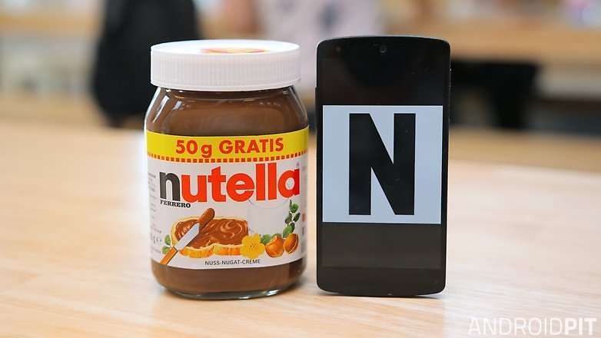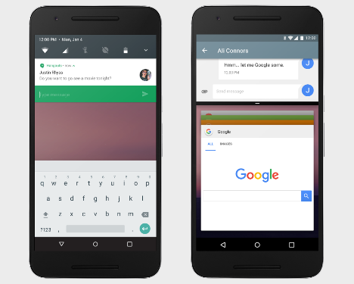
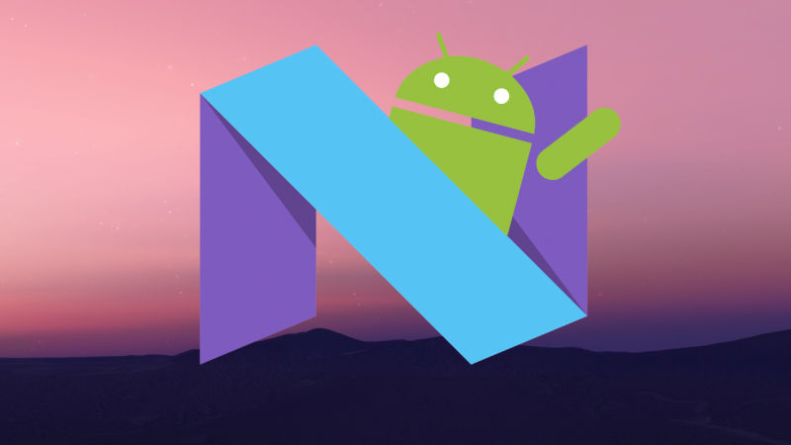
Which sweet treat will become the namesake of Android N? / © ANDROIDPIT
Android L became Android 5.0 Lollipop, and Android M went on to become Android 6.0 Marshmallow. This year, Google is likely to announce Android N, and Android 7.0 Nougat (or Nutella, or some other sweet treat that begins with N) should arrive a few months later.
The new Android N features may include better battery management options, the inclusion of the Dark Theme that was dropped at the last minute from Android 6.0 and possibly the implementation of native pressure sensing technology (you know, for Force Touch).
We expect the keynote speech to contain some information on Android N but there are other events that could give us a glimpse into the new version of Android. The first event after the keynote will take place at 1 PM PST and promises to give us information on new developer features in the platform as well as APIs, functionality and performance. This is one of the few events that is being live streamed.
For a full rundown of what we expect from Android N, hit our dedicated page at the link.
Chrome OS
Chrome OS might steal the spotlight at Google I/O 2016 because recent speculation has increasingly suggested that it is to be unified with Android. This would bring the laptop and mobile experience together like never before.
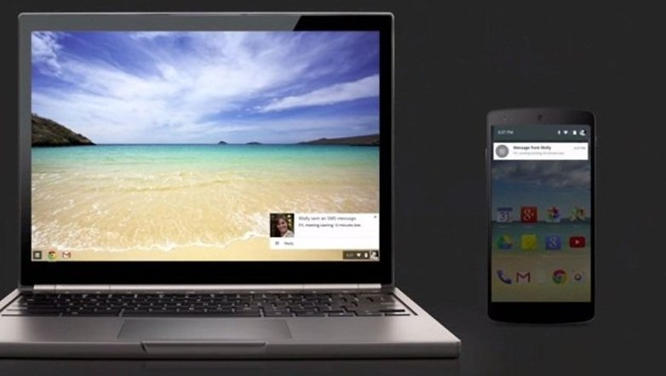
Chrome OS may steal the spotlight at Google I/O 2016 / © ANDROIDPIT
Google representatives have denied the rumors, but the two systems have been talking over each other for a while now. With the hardware lines between devices becoming ever blurrier – the Pixel C is certainly more 'netbook' than earlier Google tablets – Google is likely to make this move sometime soon. Hopefully, it is more successful than Windows' attempts at mobile and desktop unification.
There is an event that takes place on May 19 at 11 AM called 'Fast and resilient web apps' that could give us clues into Google's next steps in web browsing. The event will showcase the "best practices and critical tools of APIs available in the browser that will enable you to deliver a great user experience".

Virtual reality & 3D Vr Glasses
MWC saw a very heavy emphasis on VR, with the Galaxy S7 coming bundled with a Gear VR upon preorder and Facebook's Mark Zuckerberg proclaiming the technology to be vital to the future he has envisaged.
Picking apart the truth from the bluster may be a tricky task, but Google is unlikely to make things easier at I/O, where at least one VR-related announcement seems highly likely. The company has created its own Virtual Reality division and is said to be working on a new, standalone VR headset.
There are two major events scheduled at Google I/O 2016 that preview where Google sees VR going in the future. Both take place on May 19. The first is VR for Google at 9 AM PST and will reveal what Google has learned about VR and where we are headed in the future. This event will be live streamed on YouTube so it should be a big one. The next event starts at 2 PM is about how VR will affect the movie watching experience.
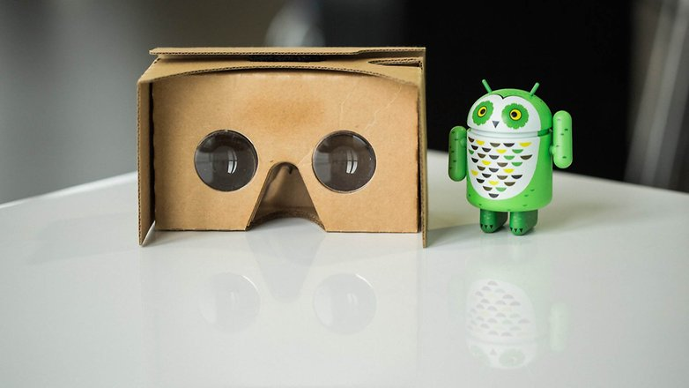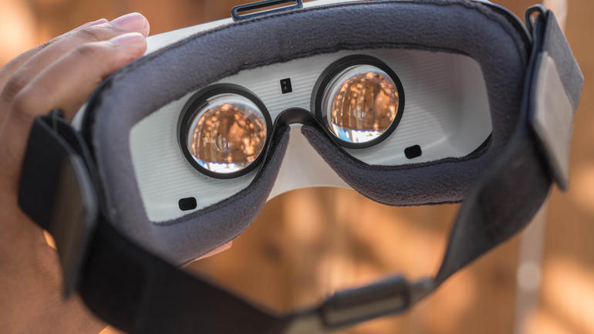
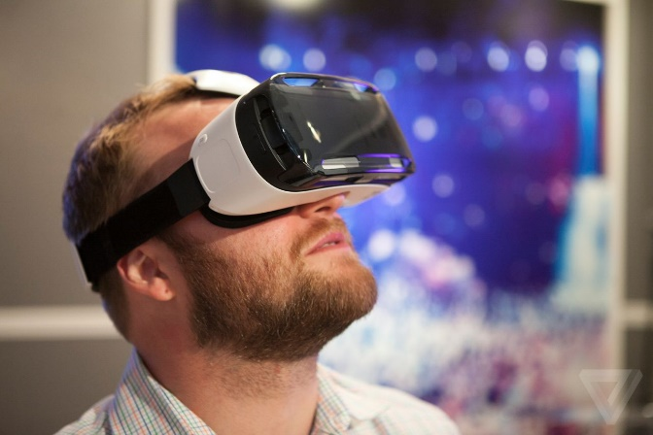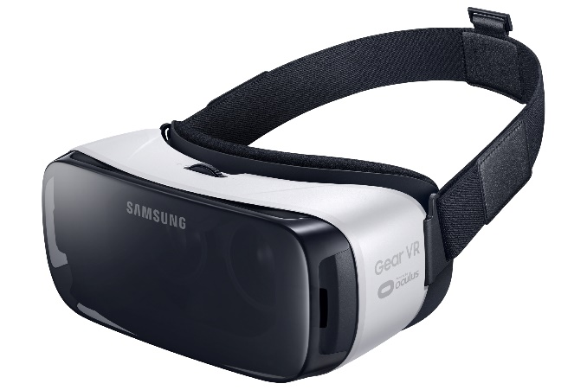
VR for the masses could see an expansion at I/O this year. / © ANDROIDPIT

Android Wear
Whether or not now is the time to buy a smartwatch, Google took some strides with smartwatches in 2015, adding better gesture support and native Wi-Fi capabilities.
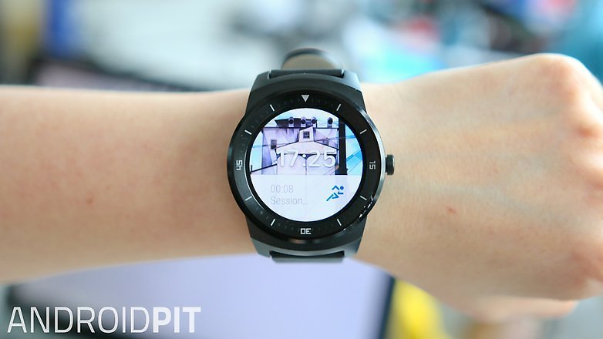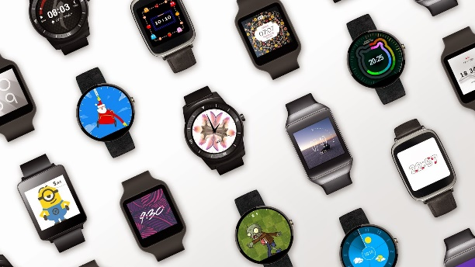
Android Wear is becoming more independent. / © ANDROIDPIT
Smartwatches are certainly becoming more independent from Android smartphones but what lies ahead for them is still a bit of a mystery. Google may announce further improvements to voice control, more gesture controls and potentially some new devices, but the technology really needs a big injection of something potent to get it going, as smartwatches seem to be languishing in technology limbo at the moment.
In addition, as Android Wear became iOS compatible in 2015, so don’t be surprised if it’s announced as Windows Phone compatible this year.
Apple Watch
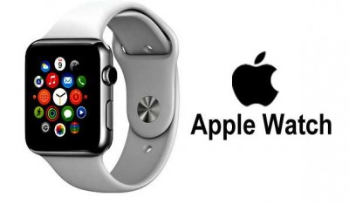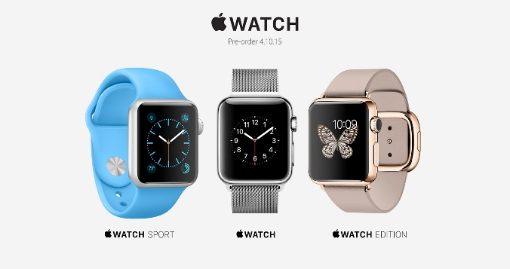

Android Auto
Google is running a little behind on providing attractive solutions in the automobile sector, but Google I/O 2016 could change that. Android Auto is on the rise and we will likely see manufacturers announce new car models compatible with Google's system.
There is also the expectation that more third-party applications will become compatible with the system. In 2015, Waze (which is part of Alphabet, the holding company of Google) executives stated that the intelligent navigation system could be inserted into the Android Auto. Google I/O is the perfect place to promote this.
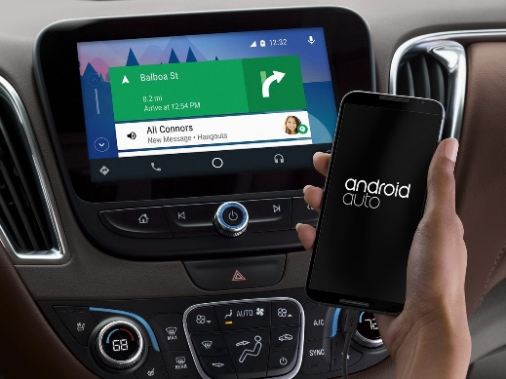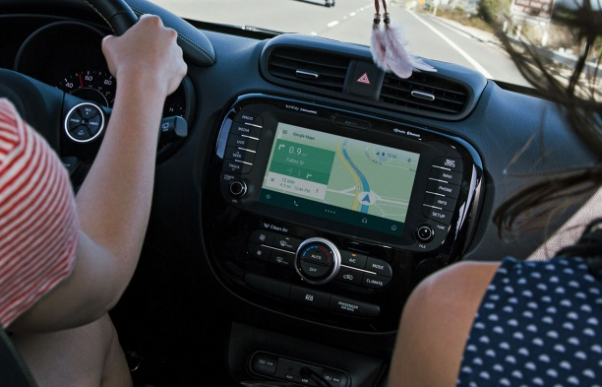
More and more car makers are picking up Android Auto. / © ANDROIDPIT

Apple Car Play

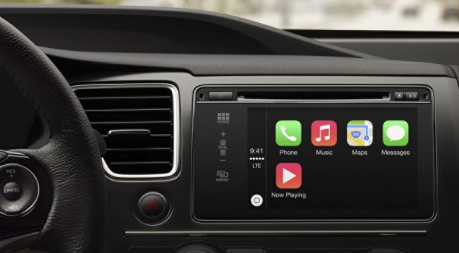

Self-driving cars
The autonomous car is another project Google is working on. Last year was turbulent, with Google’s prototype gettinginvolved in an accident with injuries for the first time: although that accident, and all subsequent incidents, have been found to be a result of human error, with drivers finding the Google cars' intentions difficult to predict.
At Google I/O, we should see a presentation on figures for the tests and what’s next for the prototype. The location that Google has chosen for this year's I/O also lends itself to a demonstration of a fleet of self-driving vehicles.
The first Android Auto event will start on May 18 at 6 PM PST. This event will showcase how Android Auto could open up new opportunities for developers to reach customers during their driving time. Since the focus is on self driving cars we could expect future drivers to have free time in the car.
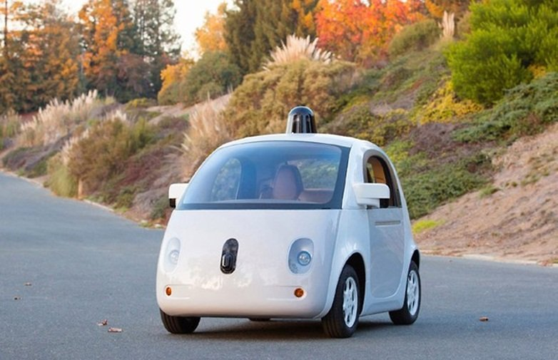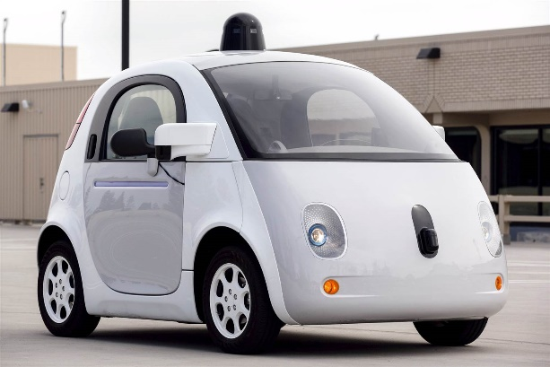
Google Car: an I/O 2016 centerpiece. / © Google

Project Ara
We’ve been hearing about Project Ara, Google’s modular smartphone, since 2013 but it’s still yet to be released. In 2015, the company hoped to launch a test version of it in Puerto Rico, but this was met with delays and the launch was eventually canceled.
The official Project Ara Twitter page confirmed that the device will go on sale (in some guise) in 2016, somewhere in the US, but specifics are still unknown. Google I/O 2016 should provide more concrete details.
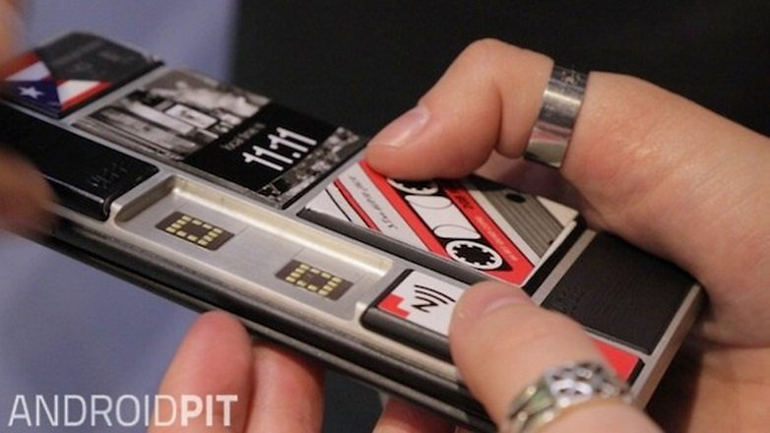
Project Ara will undoubtedly be discussed at I/O 2016. / © ANDROIDPIT

Nexus 7 (2016)
Google’s 7-inch tablet, the Nexus 7, was first launched in 2012 in co-operation with Asus. It was last updated in 2013, and rumors suggest it will make a comeback in 2016 with a tablet manufactured by Google’s new friend, Huawei.
The expectation is that the Nexus 7 (2016) will have a metal body and lower price than the Pixel C but maintain the 7-inch screen. Interesting.
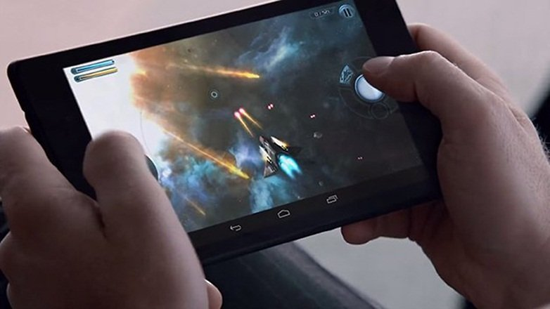
The Nexus 7 (2016) should also be announced at Google I/O 2016 / © ANDROIDPIT

A new messaging application
If there's one area in which Google can't stand up against the competition, it’s messaging applications. 2016 will be a good year for the company to reverse this situation.
Some rumors suggest that the Mountain View giant plans to launch a new messenger application. The big difference would be the use of artificial intelligence, employing chatbots to send replies and suggest answers within the app. We shall see.
Google certainly has plans to turn around the SMS platform, and we will likely hear more about this at I/O.
Project Tango
Augmented reality may be the next big thing, taking the best of virtual reality and amplifying it, but it's still relatively early days. The technology uses motion-tracking and depth sensing to build a 3D world onto physical surroundings. At CES in January, Lenovo announced that it will be bringing a Project Tango smartphone to the consumer market this summer. We can expect to hear more on this at I/O.
The first Project Tango event will take place on May 18 at 1 PM PST and will show you how to build a Project Tango game with a guide to development. The second Project Tango event will take place on May 18 at 4 PM PST and will give you the basics of concepts of area learning.
There are two Project Tango events on May 19. The first starts at 11 PM PST and will be a panel that discusses how Project Tango will shape our lives in the future. The other event will begin at 3 PM and will over how the project will launch in the first consumer phone.
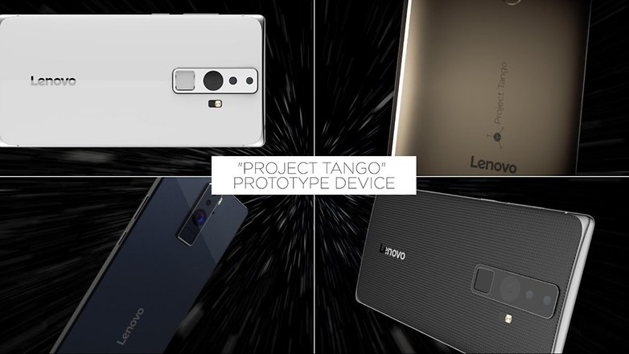
Lenovo's Project Tango smartphone is still in the prototyping phase, but a summer launch is scheduled. / © Google

Project Fi
Google's cross-carrier network, Project Fi, automatically switches carriers, providing more reliable access to mobile data. It also evaluates open Wi-Fi connections and uses those if they meet certain criteria. Currently, Project Fi is only available for Nexus owners, but I/O might mark the occasion when the service sees an expansion to include other devices.
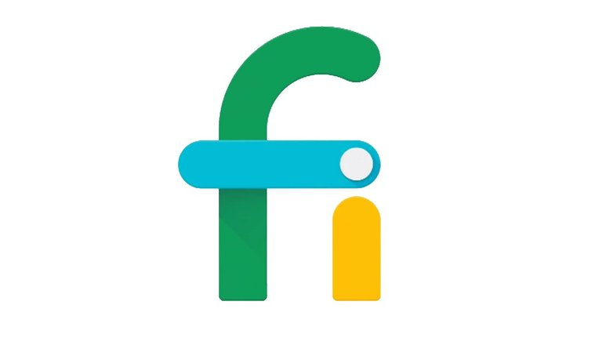
Project Fi could finally see an expansion to non-Nexus devices. / © Google

Double Lense Camera Phone.
Huawei just pulled the wraps off the Honor V8 flagship at a launch event in China. The smartphone brings some Huawei goodness to the Honor sub brand, namely the top-end Kirin 950 chipset and the dual-camera setup on the back (though no Leica branding here).
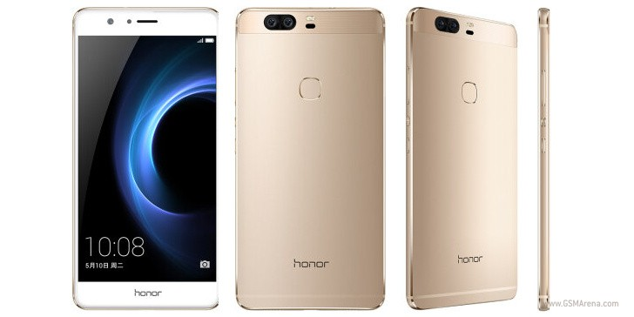
The Honor V8 sports a 5.7-inch display and you get to choose between FullHD and QHD resolution - Huawei finally caved in, after long refusing to go beyond 1080p. Both variants use IPS panels and have a 2.5D glass on top.
The Kirin 950 chip we already mentioned comes with an octa-core CPU (4xCortex-A72 + 4xCortex-A53 clusters). RAM is set at 4GB, and the QHD display is coupled with 64GB of storage, while the FullHD flavor gets half that.
The dual cameras on the back of the Honor V8 look an awful lot like the equipment of the Huawei P9 - 12MP each, 6-element lenses with f/2.2 aperture, dual-LED flash and laser autofocus. The big absentee is the Leica badge. On the front you're getting an 8MP f/2.4 cam, the P9 says "hi" once again.
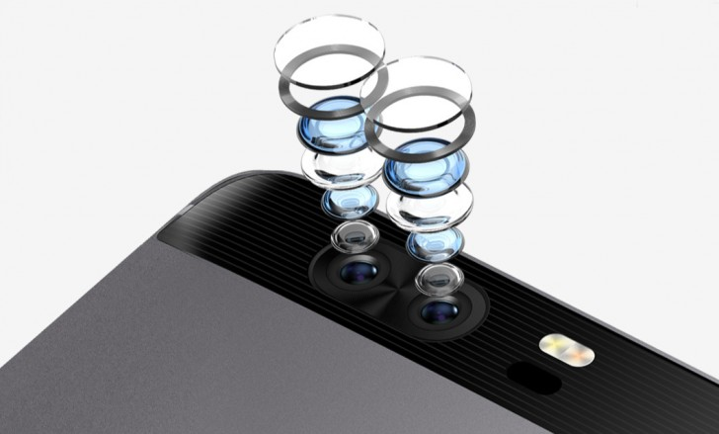
Connectivity is well covered, with all models supporting LTE, Wi-Fi ac, Bluetooth 4.2 and GPS. The base model does lack support for NFC though. The metal-clad smartphone measures 157x77.6x7.75mm and weighs 170g. Battery capacity is listed at 3,500mAh, and charging takes place via a USB Type-C interface.
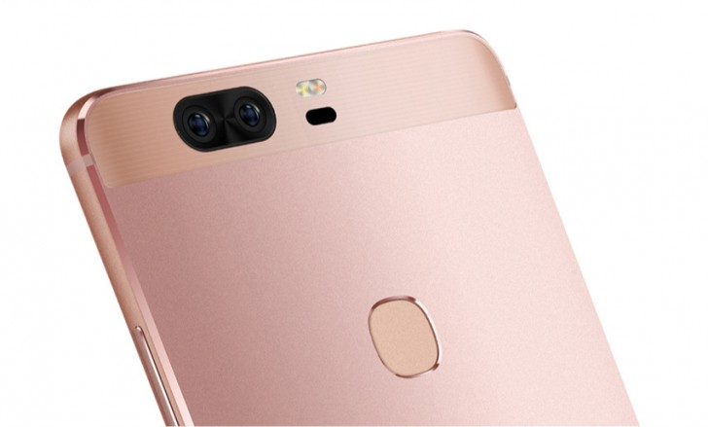

That new Windows is Windows 10.
Windows 10 represents the first step of a whole new generation of Windows. Windows 10 unlocks new experiences for customers to work, play and connect. Windows 10 embodies what our customers (both consumers and enterprises) demand and what we will deliver.
Windows 10 will run across an incredibly broad set of devices – from the Internet of Things, to servers in enterprise datacenters worldwide. Some of these devices have 4 inch screens – some have 80 inch screens – and some don’t have screens at all. Some of these devices you hold in your hand, others are ten feet away. Some of these devices you primarily use touch/pen, others mouse/keyboard, others controller/gesture – and some devices can switch between input types.

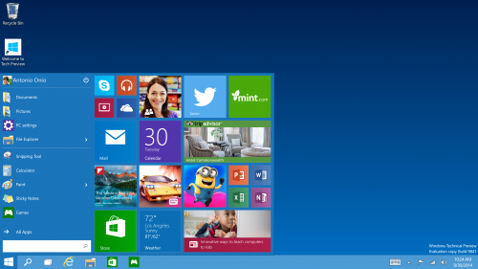
Start menu: The familiar Start menu is back, but it brings with it a new customizable space for your favorite apps and Live Tiles.

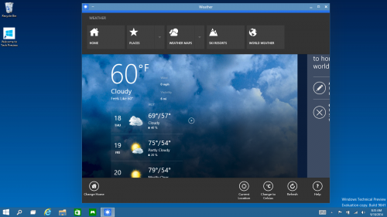
Everything runs in a window: Apps from the Windows Store now open in the same format that desktop apps do and can be resized and moved around, and have title bars at the top allowing for maximize, minimize, and close with a click.
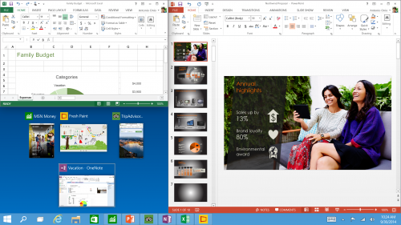
Snap enhancements: You can now have four apps snapped on the same screen with a new quadrant layout. Windows will also show other apps and programs running for additional snapping and even make smart suggestions on filling available screen space with other open apps.

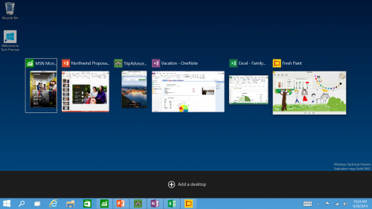
New task view button: There’s a new task-view button on the taskbar for quick switching between open files and quick access to any desktops you create.

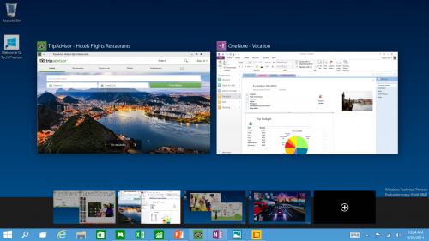
Multiple desktops: Create desktops for different purposes and projects and switch between these desktops easily and pick up where you left off on each desktop.
Find files faster: File Explorer now displays your recent files and frequently visited folders making for finding files you’ve worked on is easier.
Microsoft HoloLens
The technology industry is the most challenging and also exhilarating industry to be involved in. For this reason there are constantly massive projects being worked on for years in secret labs with code names. When these projects eventually lift their head to the surface, they have the potential to change the world as we know it.

Microsoft's latest release, HoloLens, is an example of this. Alex Kipman, chief inventor of Microsoft's Studio C, has been working on this for 5 years.

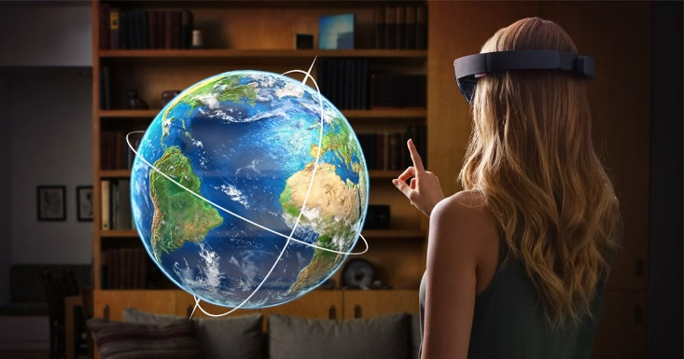

HoloLens turns the future into the present. It lets you work physically with apparent holograms by using simple voice and gesture controls. These finished products designed as holograms can then be entered into the real world via 3D printing. Truly astonishing concepts.

Project HoloLen's key achievement, realistic holograms, works by tricking your brain into seeing light as matter. It works by bouncing light particles around a so-called light engine millions of times before entering the two lenses of the goggles and ricocheting between layers of red, green and blue glass.

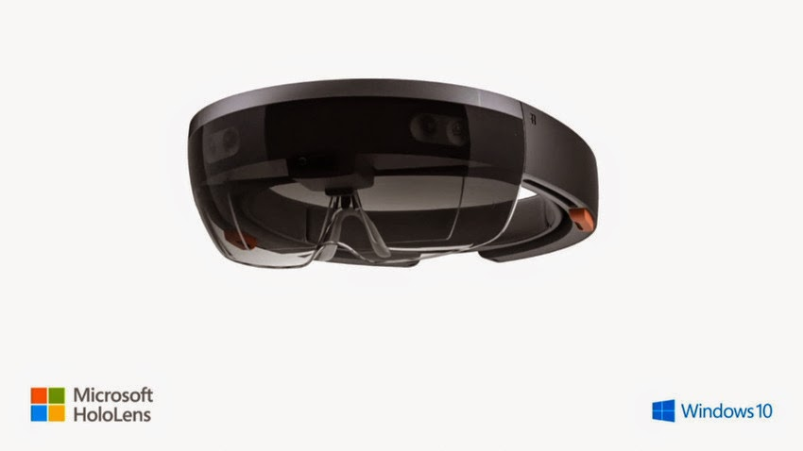

"When you get the light to be at the exact angle", Kipman says, "that's where all the magic comes in".

Microsoft is declaring this experience holographic. But these images can only be witnessed through a pair of goggles, they are not projected into the room. To avoid much debate, Microsoft needs to define holograms to the general public.
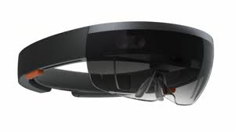
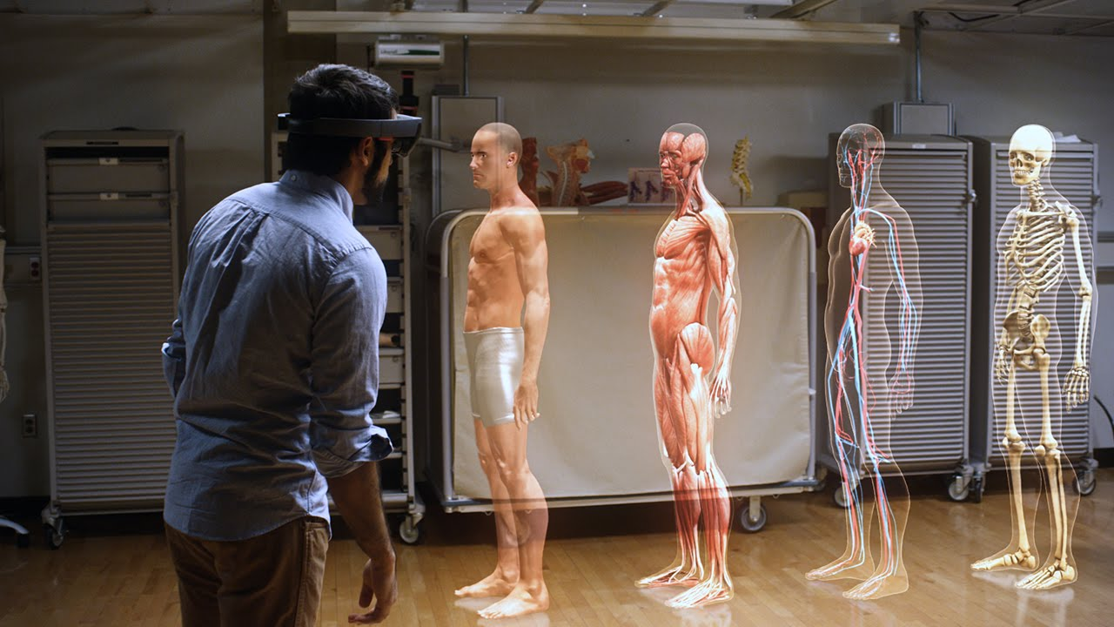

Chromecast
As previously mentioned, the Chromecast is a puck-like device with a circumference roughly the size of can of soda. The latest version comes in three distinct colors — dubbed Black, Coral, and Lemonade — each of which features three built-in antennas, a malleable HDMI cord, and support for 802.11 ac and 5 GHz bands. The device runs off a simplified version of Google’s Chrome OS, and has only 256 MB of memory, which is nothing. However, it doesn’t need to have a ton of memory because it’s not much more than a glorified gateway. It gets plugged into your HDTV’s HDMI port, connected to your home’s Wi-Fi network, and acts as a portal for the content on your mobile devices to be cast onto your TV.
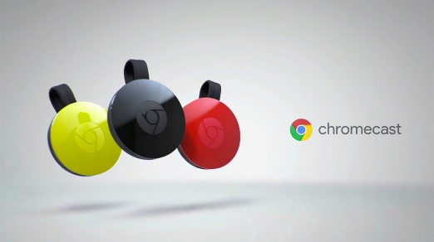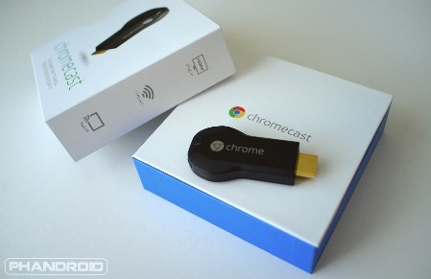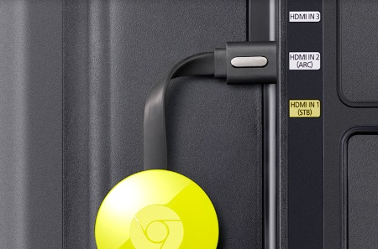
Here’s how casting works: Using apps on your mobile device or computer, you essentially hand off, or cast, content to the Chromecast. Using the information it receives about what you want to watch, the Chromecast finds the material on the internet and streams it directly from the source. This way, your phone or tablet’s resources aren’t hogged up with streaming tasks, and battery life doesn’t take a huge hit. Think of your mobile device or computer as a remote control for the Chromecast. One exception to this rule is when the Chromecast mirrors your Chrome browser on your computer. In this case, the Chromecast is depending entirely on your computer as the source for what it displays. The other exception is an app called AllCast, which we dig into a little bit further along.

What devices work with Chromecast?
Thanks to its “all devices” philosophy, Chromecast can run on Android tablets and smartphones, iPads and iPhones, and Chrome for Windows and Mac OS X. However, those with BlackBerry or Windows phones are out of luck… for the most part. An app called Tube Cast offers some limited YouTube functionality for Windows phones over Chromecast; but for now, it’s safe to say that functionality is extremely limited at best.

Intel Compute Stick

Intel launched the first iteration of the Compute Stick back in March of 2015, and ever since, a number of other stick PCs have picked up on the Intel’s standard specs and carried them. The most recent version of the Compute Stick is powered by a quad-core Intel Atom x5-Z8300 processor and 2GB of RAM, with 32GB of eMMC storage. As for connectivity, it attaches to a TV or monitor via HDMI, and utilizes a pair of USB ports — one 2.0 and one 3.0 — a MicroSD slot, and a micro-USB for power. It also features Bluetooth 4.0 for keyboard and mouse support, and 802.11ac Wi-Fi.
There’s also an older model, which is currently more readily available than the new one. It has an Intel Atom Z3735 processor, which offers compute performance similar to the Z8300, but slower integrated graphics. The old model also has one less USB port and only 802.11b/g/n Wi-Fi. It’s probably wise to wait for the new edition, unless you can grab the old one at a bargain price.
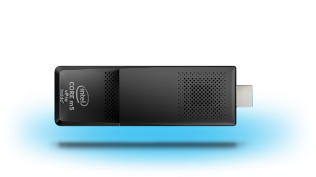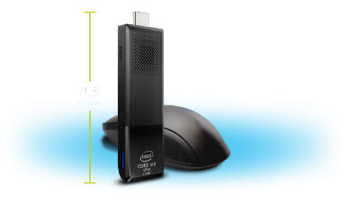
Apple TV
For the last few years, Apple TV has been the only way I've watched movies and TV shows at home. Since I live outside the U.S., that's primarily meant iTunes, Netflix, and AirPlay from the local network apps on my iPhone and iPad. It's been good enough, at least, that I've never felt the need to go running back to cable. But I've always wanted more.
As the months and years ticked by from the last Apple TV refresh in March of 2012, I've increasingly wanted a modern box set free of its limitations and allowed to truly deliver on its iOS foundations—the same foundations that power the tremendous platform behind the iPhone and iPad. And now, with the fourth generation Apple TV, Apple is delivering something that promises to be just that. It's been a long time coming. Too long, frankly. But is it really, finally here?
The fourth generation Apple TV was both too long in coming and too quick out the door. Frustratingly rough edges abound. Yet it manages to deliver something truly remarkable: A solid experience out of the box, and an amazing foundation for the future. If you want iTunes, Netflix, and more on your television, Siri voice control and full-on apps, you want the new Apple TV.

Performance
Inside the new Apple TV is a dual core Apple A8 system-on-a-chip (SoC). It pairs a second-generation 64-bit "Typhoon" central processor with a PowerVR GX6450 graphics processor. It's the same SoC found in the iPhones 6 and iPad mini 4. It's not as fast as the new Apple A9-series found on the iPhones 6s, but it's an exponential upgrade from the single core Apple A5 SoC in the previous Apple TV and it's more than enough to push around the pixels and bits of the new Apple TV.
There's 2 GB of memory as well, same as the latest iPhones and iPads, which is great to see. And you can get it with either 32 GB or 64 GB of NAND flash storage. That's interesting given most iOS devices have used the traditional three tier approach to pricing. The new iPad Pro also comes in only two tiers, 32 GB and 128 GB, so its likely something specific to how Apple sees these products selling. I don't know if a 128 GB Apple TV would eventually make sense, but time will tell.
